Jenkins-Selenium XFramium JAVA Framework Integration

**Jenkins Job Configurations:**

1. Create New Jenkins Job by clicking on *New Item*

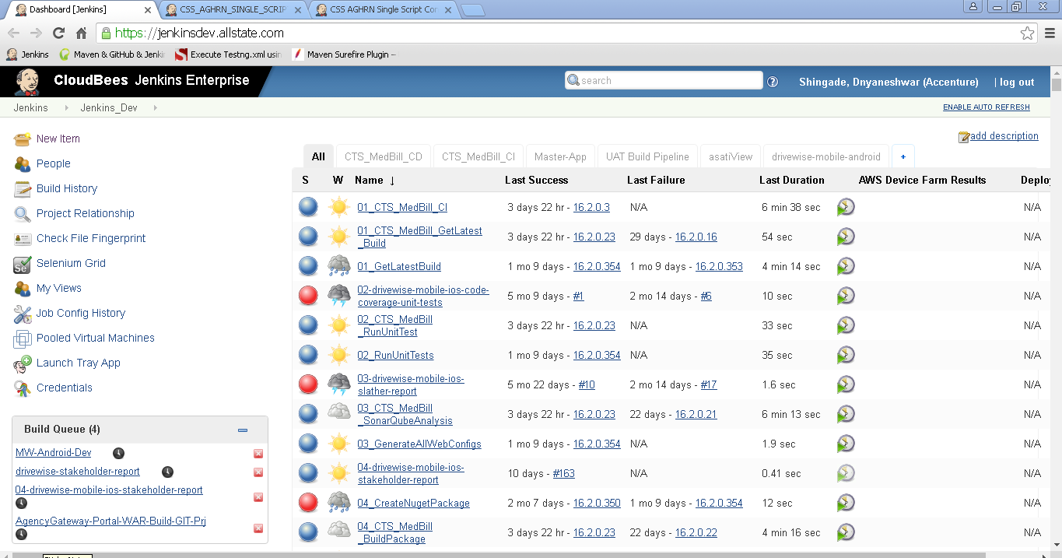

2.Give unique project name and select project type as *Maven Project* > Click on *OK* Button

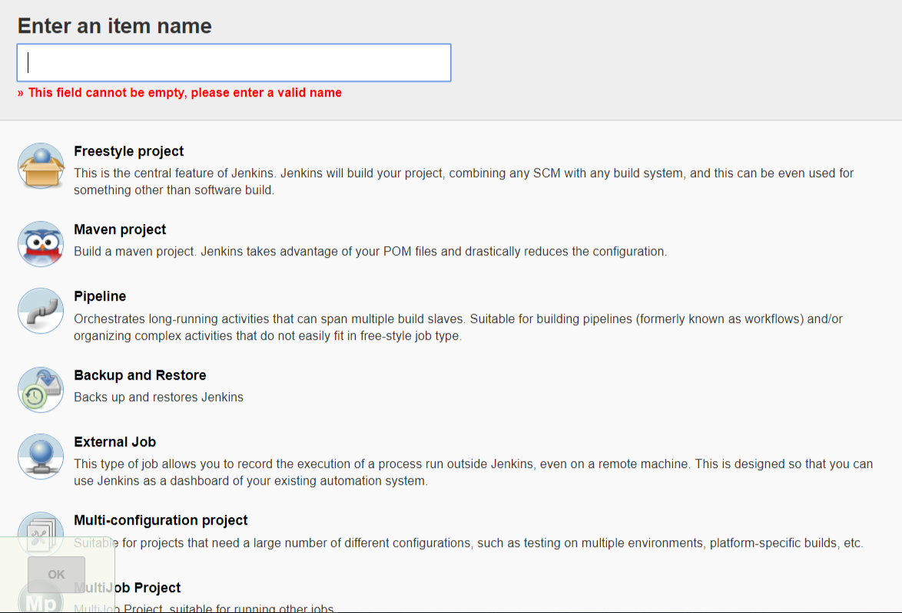

3.Verify the Project Name and enter *Description* (Optional)

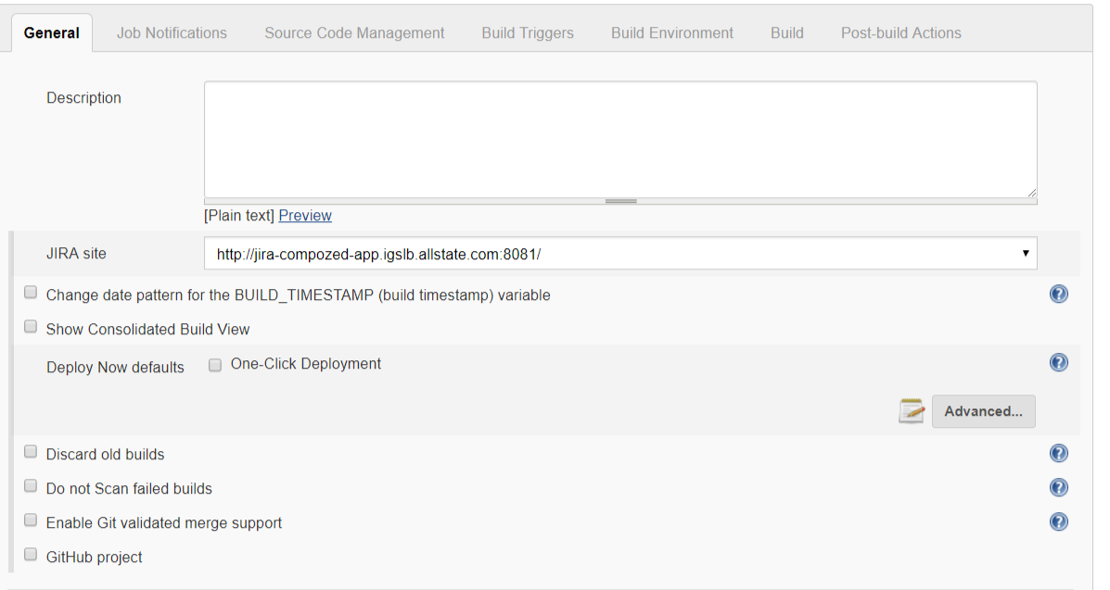

4.Select the *GitHub project* option and enter project repository URL

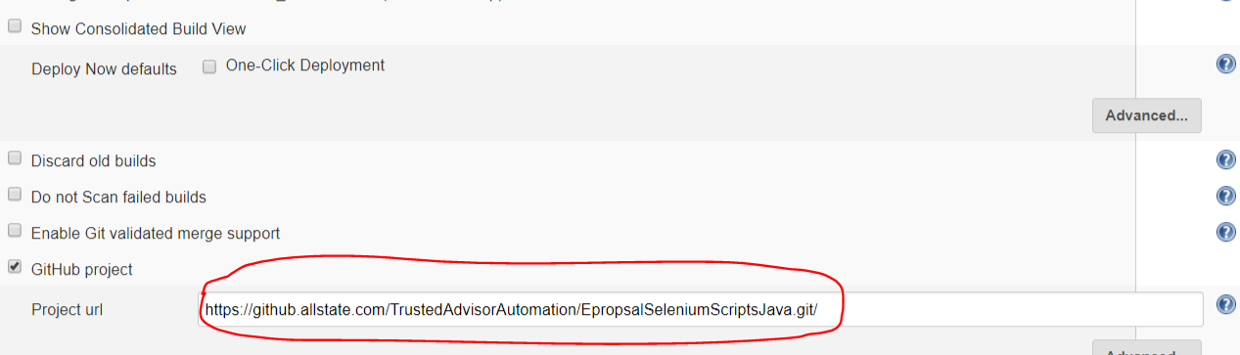

5. Select the JDK configuration as *Windows* for Class Path settings in Slave Machine

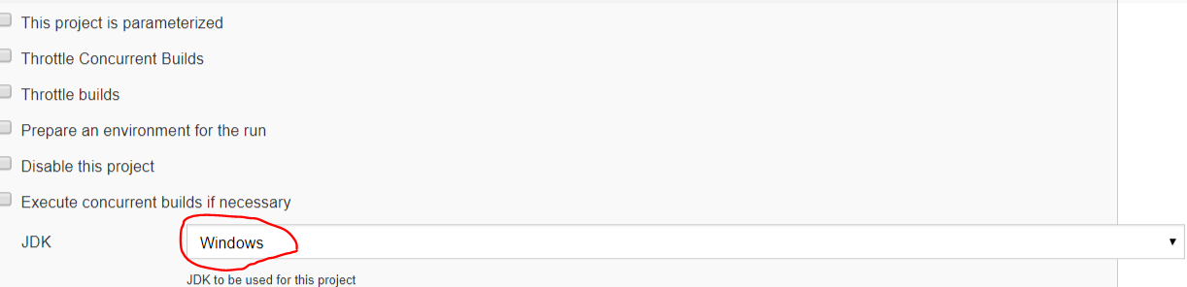

6. Select the option *Restrict where this project can be run (*to execute scripts on Jenkins Slave Machine) and enter the *Slave Machine Label* in Label Expression

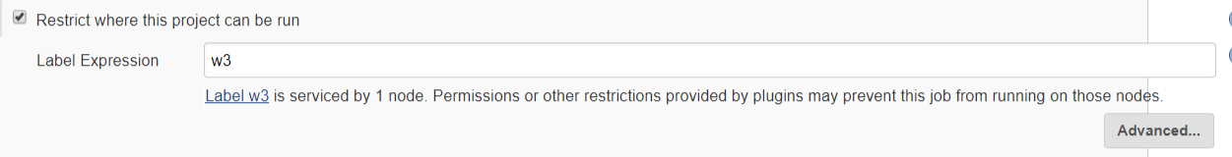

7. Select the option *Git* and Enter the Git Repository details in following format:

* **Repository URL:** git@github.allstate.com:<repository name>
* **Credentials:** SYS-ISJenkins (It is a super user and have access to all Git Repositories)
* **Branch:** Enter branch name through which you want to pull and execute the code
* **Repository browser:** (Auto)

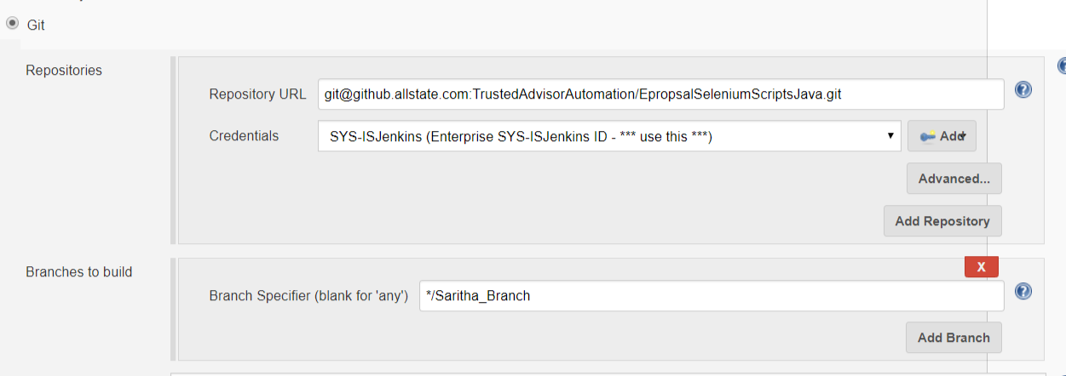

8. Verify *Build whenever a SNAPSHOT dependency is built* option is selected

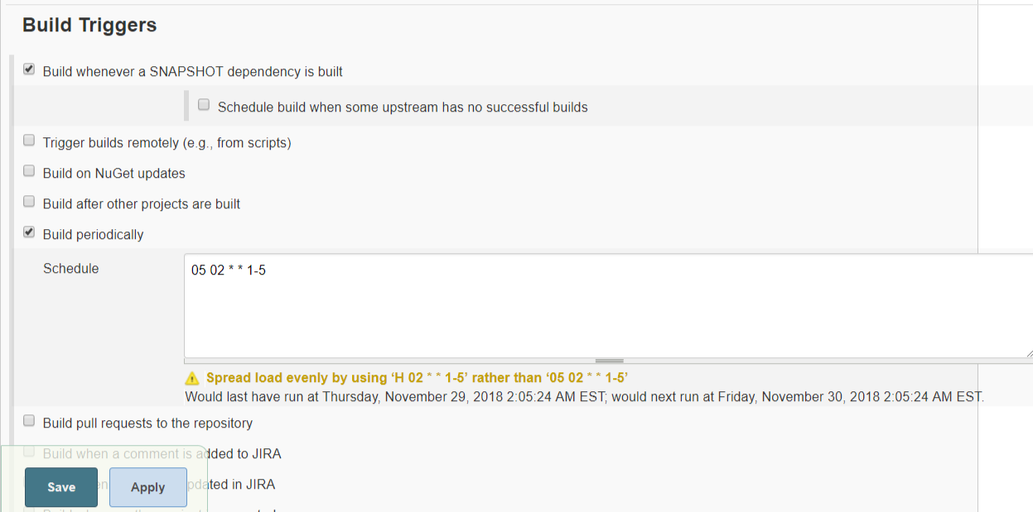

9. Set the relative path for pom.xml file and set maven commands (Goals) as shown below

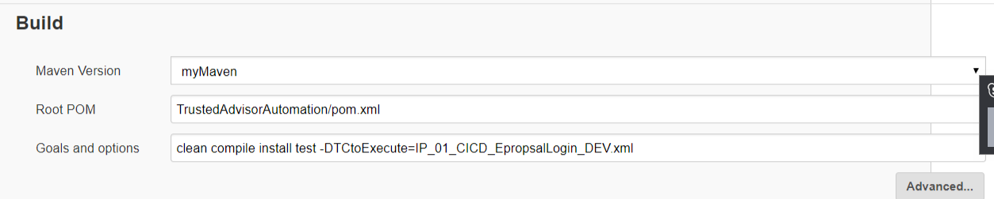

10. Set TestNG result/report pattern

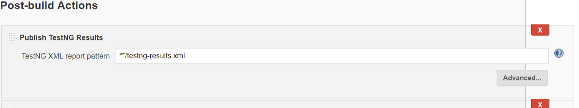

11. Set the *Editable Email Notification* option from *Add post-build action* select list > Set the recipient email Ids in *Project Recipient List* section

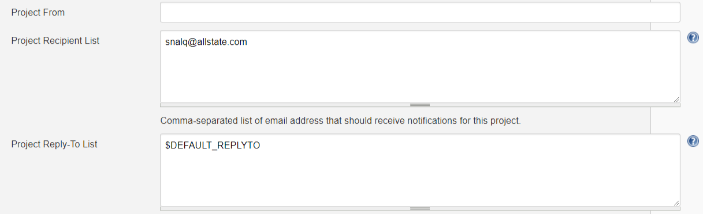

12. Set the email structure according to your requirements. Refer below screenshot for reference

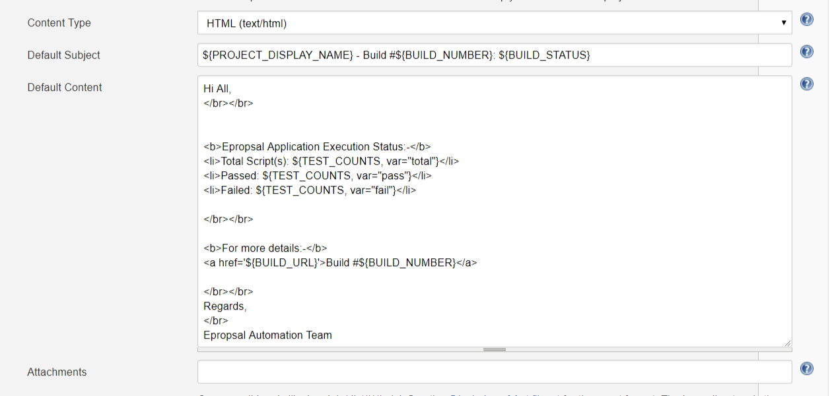

**POM.xml Configurations:**

1. To execute TestNG xml file, you need to add Maven Surefire Plugin in pom.xml. Please find below configuration for more details:

